**ROAD ACCIDENT SAFETY SYSTEM**

-REGARDING PRONE AREA

**BATCH-4**

**TEAM MEMBERS:**

**19P31A0588 – G.VEERA DURGA JYOTHI**

**19P31A0573 – RAJ KUMAR**

**19P31A0598 – N.PRATHYUSHA**

**19P31A05B7 – DURGA PRASAD**

**20P35A0511 – S.DILEEP KUMAR**

**ABSTRACT:**

We are seeing that some of the road accidents are happening due to lack of prone-area caution board. So, basically the idea of “Road accident safety system” is to help the people by using a mobile application regarding safety alerts while moving on the road based on the location and if the accident occurs it also provides the help feature which will send a message or call to the predetermined persons. This application shows the heat map of accident points. This Application works only with Mobile Data / Wi-Fi and also user needs to activate the Location / GPS Settings for getting the Accurate Point in the Map and also to get alert about an accident-prone area the application must be running in the foreground.

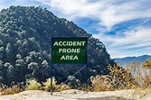

**USER ACCESS MODES:**

Mobile application /website

**AREA OF RELEVANCE:**

Public people

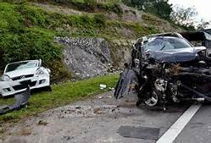

**SOFTWARE REQUIRED:**

* React native and native base for the frontend.
* PHP for handling backend of a web interface.
* Mysql for a database to store data .

**ER DIAGRAM :**

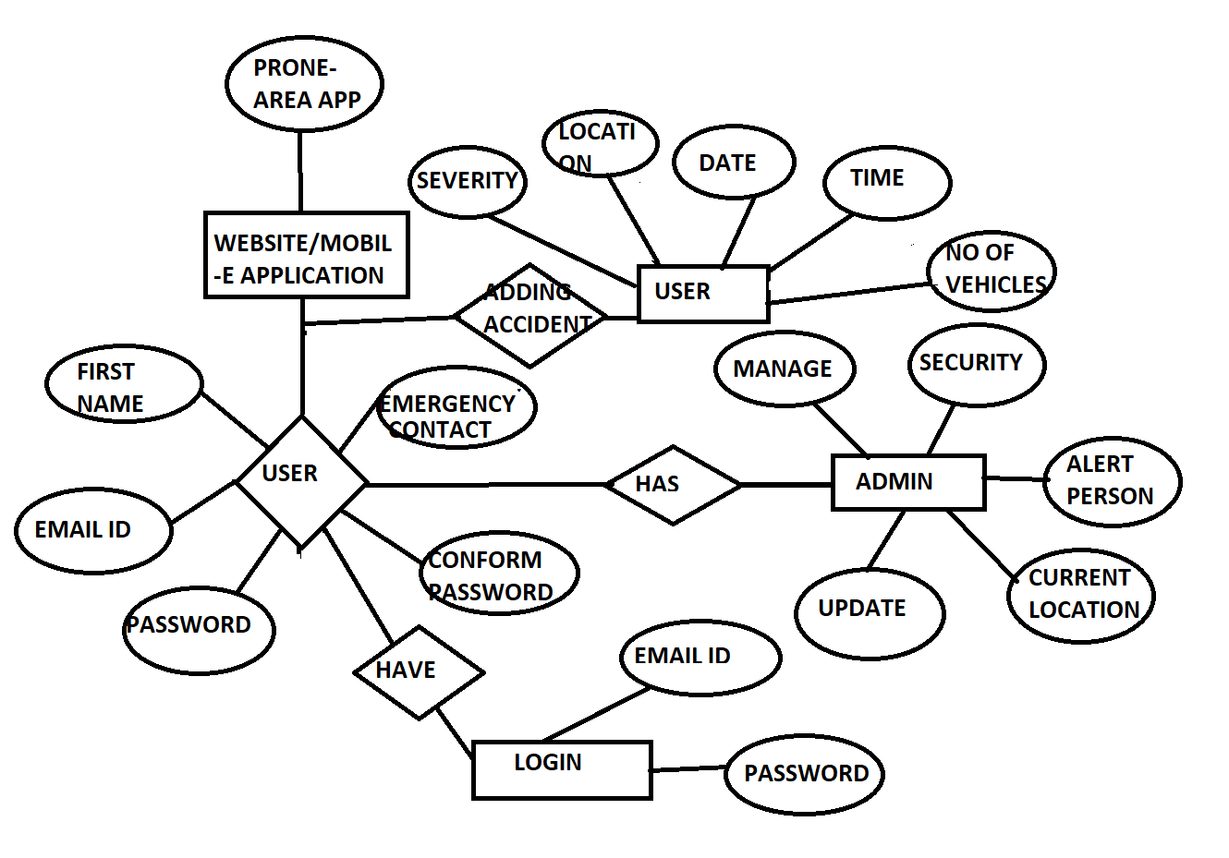

**TABLES:**

**TABLE FOR USER REGISTRATION**

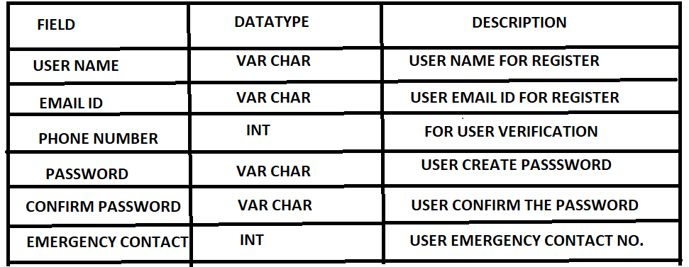

**TABLE FOR USER LOGIN**

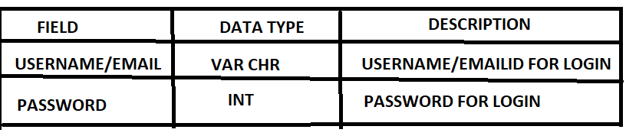

**TABLE FOR ADDING THE ACCIDENT**

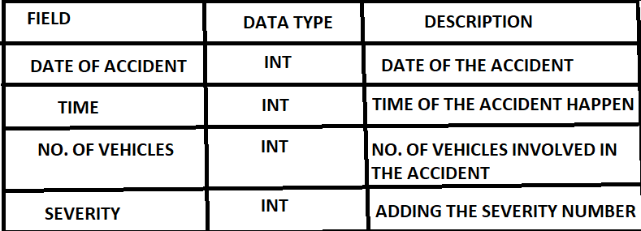

**DATA FLOW DIAGRAM:**

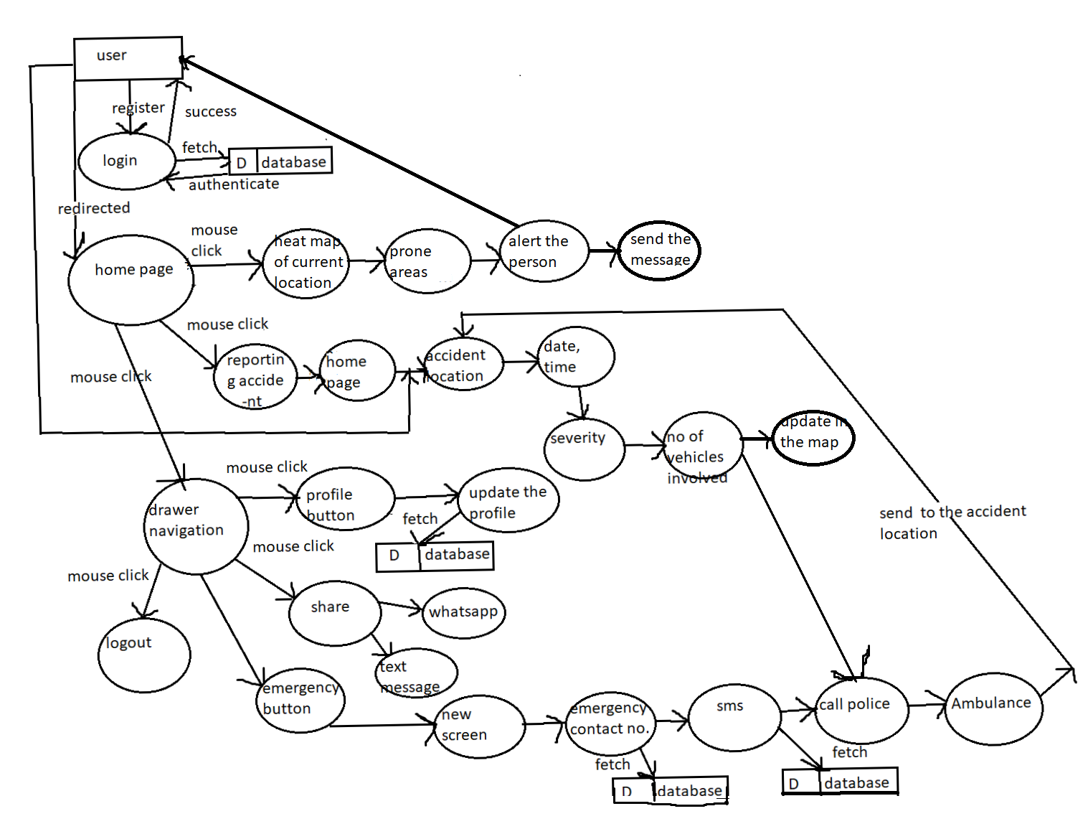

In this phase ,a complete data flow diagram of the working system is designed.This data flow

Will show the data transfers from one process to another process.

**UI DESIGN:**

In this phase,the ui or the user interface of the project is developed .That is,,the designing of the pages of the application which the user will use to interact.

**WORKING OF APPLICATION:**

1. **Register / Login**:

* If a user is not registered then he/she has to signup for this application, where a user has to give name, email, password and emergency contact number.
* If the user is registered then he/she can login by entering email id and password.

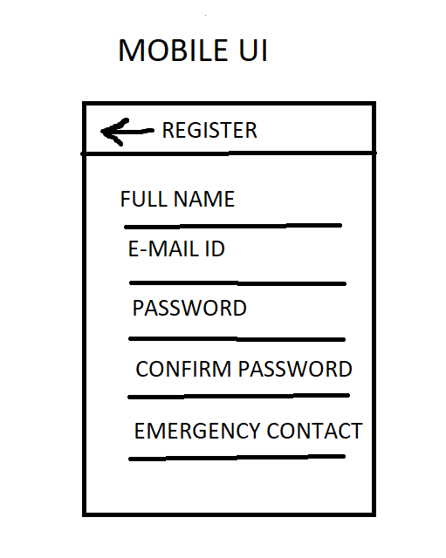

2.**Home screen**

* Once a user is successfully logged in then application opens the home screen page.
* Home screen page displays the heat maps which are the accident points and also shows the user current location.
* A user can navigate the map to see the heat maps of different areas.
* The home screen has three buttons, one for reporting an accident, one for current location and one for drawer navigator.
* While traveling when a user enters the accident-prone areas, the application shows the safety alert on the screen with vibration.

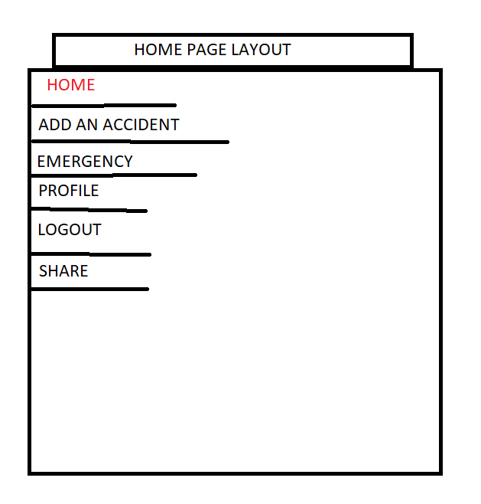

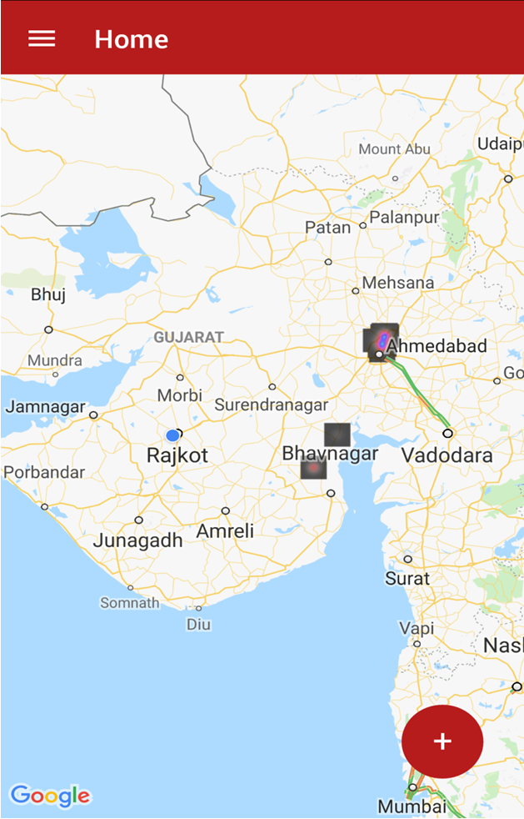

3. **Current location button**:

By pressing that it will shows current location of the user in the map.

4. **Adding accident:**

* By pressing this button user is redirected to a new page where the user has to provide the marker(coordinate) for accident location.
* After providing the accident location, a user is asked for the date, time, severity, number of vehicles involved in the accident.

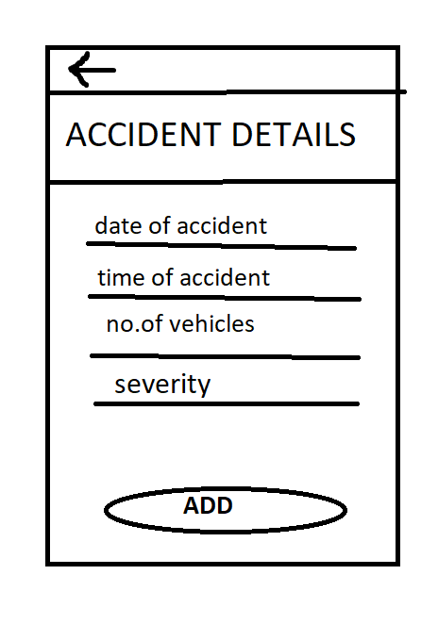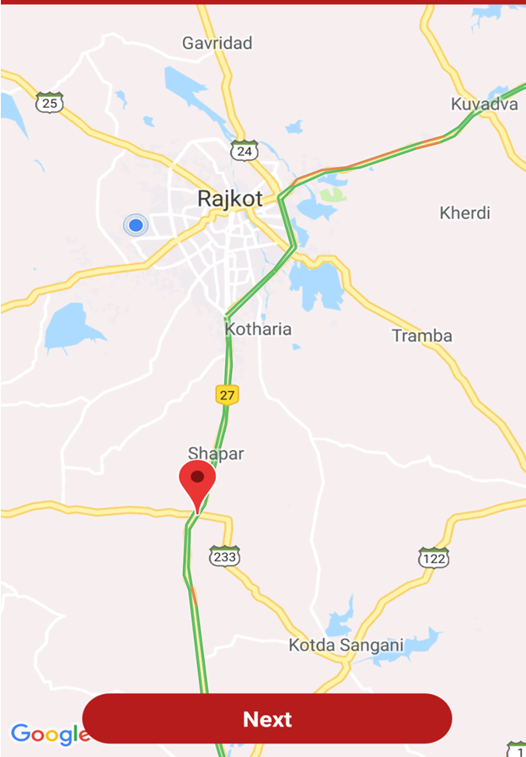

5. **Drawer navigation:**

* Drawer navigator provides basic features.
* Drawer navigator has a home button which redirects to the home screen from any screen.
* Drawer navigator has a profile button which displays the user details. A user can also update some information like password, name, emergency contact number.
* Drawer navigator has a share button which is useful for sharing this application easily on WhatsApp, text message etc.
* Drawer navigator has an emergency button which will be useful in case of emergency or accident. By pressing this button, it will redirect to another screen which has the options to call on emergency contact number, SMS the current location to emergency contact number and also to call the police and ambulance.
* Drawer navigator has the log out button which will log out the user from application.

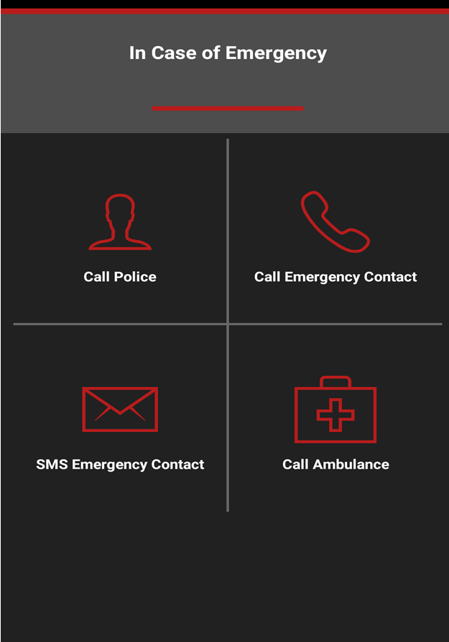

**FLOW CHART**

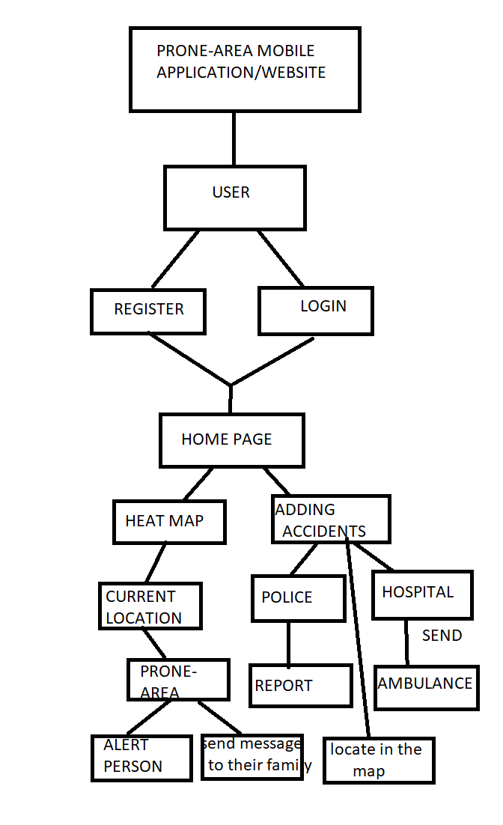

**BUSINESS LOGIC:**

* Business logic is the programming that manages communication between an end user interface and a database. The main components of business logic are business rules and work flows . A business rule describes a specific procedure; a workflow consists of the tasks, procedural steps, required input and output information, and tools needed for each step of that procedure.
* Users logins through app/website of accident prone area with his credentials

like his/her name. email id and password. If credentials are valid then he/she can enters the home page of the app. If he wants to went to a unknown place first he should on the GPS settings in his mobile so that it shows the heat map of the current location so if any prone areas occurs while the person travelling it will alert them by showing red mark on that place/by vibrating the phone. So by seeing the person can alert .if he enter into prone area, the emergency contact number which he already given while they registering will get the message .

If any accidents happen they can add the details of the accident in this app .so the details will be send to near police station /hospital ,by adding the accident details it will mark that area .so the persons who are travelling in that area will be alert.

**LIMITATIONS:**

* This app will be work when there is a wifi /mobile data connection.
* The person should have a mobile phone.

**ADVANTAGES:**

* If a person came to a unknown place so that she/he can be alert.
* Accidents happening will be reduce.
* Police will find out in which place accidents are happening more so that they can

Find out the solution and rectify the problem.

**CONCLUSION:**

* This project is used to help the people in identifying the prone areas and to alert them while there are travelling. If any accident happen to them/from surroundings they can add their details through this app so that it sends information to near their police station/hospitals .